

A

Project on

Deep Learning

Fundus Image Analysis For

Early Detection of Diabetic Retinopathy

By

Mr. Bipin Rupadiya

[Bipin.rupadiya@oshwaleducationtrust.org](mailto:Bipin.rupadiya@oshwaleducationtrust.org)

Assistant Professor,

Shri Jaysukhlal Vadhar Institute of Management Studies(JVIMS),

Jamnagar



1. **INTRODUCTION**

1.1 Overview

1.2 Purpose

1. **LITERATURE SURVEY**

2.1 Existing problem

2.2 Proposed solution

1. **THEORITICAL ANALYSIS**

3.1 Block diagram

3.2 Hardware / Software designing

1. **EXPERIMENTAL INVESTIGATIONS**
2. **FLOWCHART**
3. **RESULT**
4. **ADVANTAGES & DISADVANTAGES**
5. **APPLICATIONS**
6. **CONCLUSION**
7. **FUTURE SCOPE**
8. **BIBILOGRAPHY**

**APPENDIX**

A. Source Code

**1. INTRODUCTION**

1.1 Overview

Diabetic Retinopathy (DR) is a common complication of diabetes mellitus, which causes lesions on the retina that affect vision. If it is not detected early, it can lead to blindness. Unfortunately, DR is not a reversible process, and treatment only sustains vision. DR early detection and treatment can significantly reduce the risk of vision loss. The manual diagnosis process of DR retina fundus images by ophthalmologists is time, effort and cost-consuming and prone to misdiagnosis unlike computer-aided diagnosis systems.

Transfer learning has become one of the most common techniques that has achieved better performance in many areas, especially in medical image analysis and classification. We used Transfer Learning techniques like Inception V3,Resnet50,Xception V3 that are more widely used as a transfer learning method in medical image analysis and they are highly effective.

1.2 Purpose

* Know fundamental concepts and techniques of transfer learning like Xception.
* Gain a broad understanding of image data.
* Know how to pre-process/clean the data using different data pre-processing techniques.
* Know how to build a web application using the Flask framework.

**2. LITERATURE SURVEY**

2.1 Existing problem

Diabetic Retinopathy (DR) early detection and treatment can significantly reduce the risk of vision loss. The manual diagnosis process of DR retina fundus images by ophthalmologists is time, effort and cost-consuming and prone to misdiagnosis unlike computer-aided diagnosis systems.

2.2 Proposed solution

Transfer learning has become one of the most common techniques that has achieved better performance in many areas, especially in medical image analysis and classification. We used Transfer Learning techniques like Inception V3,Resnet50,Xception V3 that are more widely used as a transfer learning method in medical image analysis and they are highly effective.

Project Flow

• The user interacts with the UI (User Interface) to choose the image.

• The chosen image analyzed by the model which is integrated with flask application.

• The Xception Model analyzes the image, then the prediction is showcased on the Flask UI.

To accomplish this, we have to complete all the activities and tasks listed below

• Data Collection.

• Create a Train and Test path.

• Data Pre-processing.

• Import the required library

• Configure ImageDataGenerator class

• ApplyImageDataGenerator functionality to Trainset and Testset

• Model Building

• Pre-trained CNN model as a Feature Extractor

• Adding Dense Layer

• Configure the Learning Process

• Train the model

• Save the Model

• Test the model

• Application Building

• Create an HTML file

• Build Python Code

**3. THEORITICAL ANALYSIS**

3.1 Block diagram

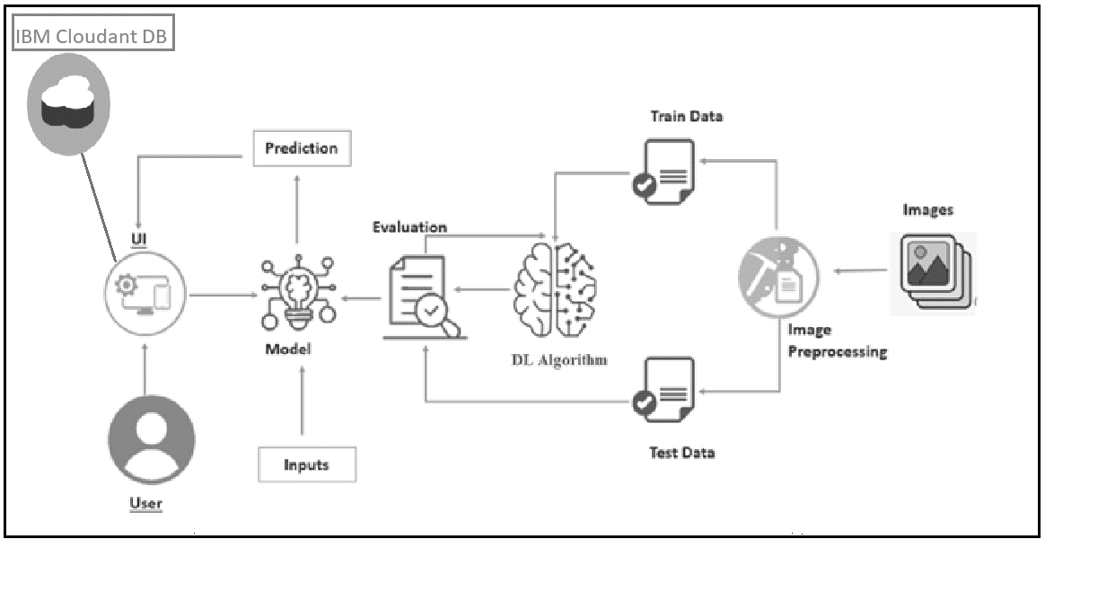

3.2 Hardware / Software designing

To complete this project, you must require the following software’s, concepts and packages

* Anaconda navigator and Spyder:
  + Refer the link below to download anaconda navigator
  + Link (Spyder) :<https://youtu.be/5mDYijMfSzs>
* Python packages:
* Open anaconda prompt as administrator
* Type “pip install numpy” and click enter.
* Type “pip install pandas” and click enter..
* Type “pip install tensorflow==2.3.2” and click enter.
* Type “pip install keras==2.3.1” and click enter.
* Type “pip install Flask” and click enter.

Prior Knowledge

* In this milestone you must have prior knowledge of following topics to complete this project.

Deep Learning Concepts

* + CNN:https://towardsdatascience.com/basics-of-the-classic-cnn-a3dce1225add
  + ResNet-50:https://towardsdatascience.com/understanding-and-coding-a-resnet-in-keras-446d7ff84d33
  + Inception-V3:https://iq.opengenus.org/inception-v3-model-architecture/
  + Xception:https://pyimagesearch.com/2017/03/20/imagenet-vggnet-resnet-inception-xception-keras/
  + Flask: Flask is a popular Python web framework, meaning it is a third-party Python library used for developing web applications.

**4. EXPERIMENTAL INVESTIGATIONS**

To accomplish this, we have to complete all the activities and tasks listed below

* Data Collection.
  + Create a Train and Test path.
* Data Pre-processing.
* Import the required library
* Configure ImageDataGenerator class
* ApplyImageDataGenerator functionality to Trainset and Testset
* Model Building
  + Pre-trained CNN model as a Feature Extractor
  + Adding Dense Layer
  + Configure the Learning Process
  + Train the model
  + Save the Model
  + Test the model
* Application Building
  + Create an HTML file
  + Build Python Code

### Project Structure

Create the Project folder which contains files as shown below

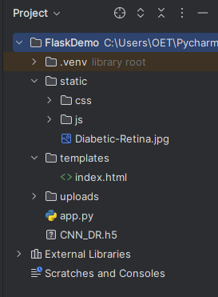

* We are building a flask application which needs HTML pages stored in the templates folder, CSS, Images stored in a static folder and a python script app.py for scripting.
* CNN_DR.h5 is our saved model. Further we will use this model for flask integration.
* Model contains model training files.

### Data Collection

DL depends heavily on data, it is the most crucial aspect that makes algorithm training possible. So this section allows you to download the required dataset.

### Download The Dataset

There are many popular open sources for collecting the data. Eg: kaggle.com, UCI repository, etc.

**Link**

https://www.kaggle.com/datasets/arbethi/diabetic-retinopathy-level-detection?select=preprocessed+dataset

We are going to build our training model on Google colab.

* Clone kaggle in google colab

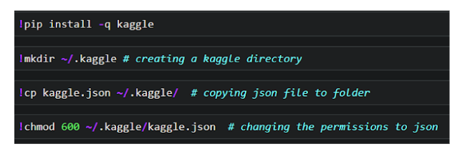

* Download the dataset

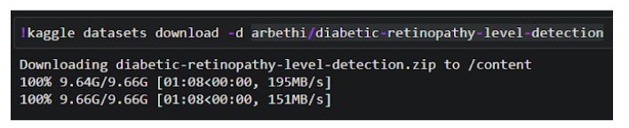

* Unzip the dataset

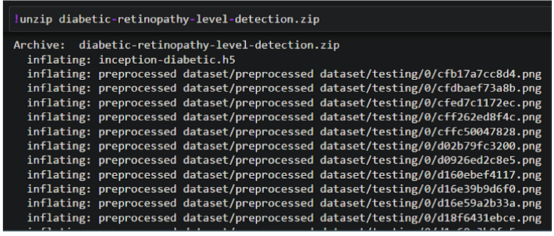

**Create Training And Testing Path**

To build a DL model we have to split training and testing data into two separate folders. But In the project dataset folder training and testing folders are presented. So, in this case we just have to assign a variable and pass the folder path to it.

Four different transfer learning models are used in our project and the best model (Xception) is selected.

The image input size of xception model is 299, 299.

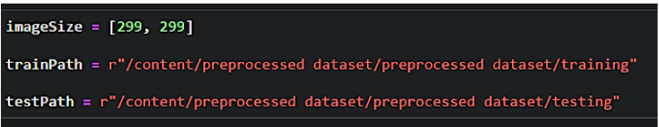

**Importing The Libraries**

Skill Tags:

Import the necessary libraries as shown in the image.

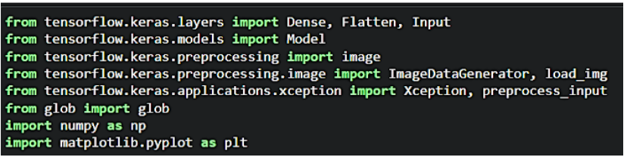

**Configure ImageDataGenerator Class**

ImageDataGenerator class is instantiated and the configuration for the types of data augmentation

There are five main types of data augmentation techniques for image data; specifically:

* Image shifts via the width_shift_range and height_shift_range arguments.
* The image flips via the horizontal_flip and vertical_flip arguments.
* Image rotations via the rotation_range argument
* Image brightness via the brightness_range argument.
* Image zoom via the zoom_range argument.

An instance of the ImageDataGenerator class can be constructed for train and test.

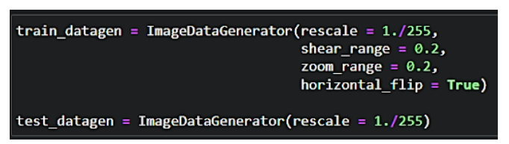

**Apply ImageDataGenerator Functionality To Train Set And Test Set**

Let us apply ImageDataGenerator functionality to the Train set and Test set by using the following code. For Training set using flow_from_directory function.

This function will return batches of images from the subdirectories

Arguments:

* directory: Directory where the data is located. If labels are "inferred", it should contain subdirectories, each containing images for a class. Otherwise, the directory structure is ignored.
* batch_size: Size of the batches of data which is  64.
* target_size: Size to resize images after they are read from disk.
* class_mode:

-  ‘int': means that the labels are encoded as integers (e.g. for sparse_categorical_crossentropy loss).

- 'categorical' means that the labels are encoded as a categorical vector (e.g. for categorical_crossentropy loss).

- 'binary' means that the labels (there can be only 2) are encoded as float32 scalars with values 0 or 1 (e.g. for binary_crossentropy).

 - None (no labels).

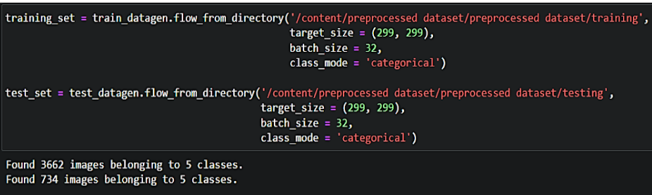

### Model Building

Now it's time to build our model. Let’s use the pre-trained model which is Xception, one of the convolution neural net (CNN) architecture which is considered as a very good model for Image classification.

Deep understanding on the Xception model – Link is referred to in the prior knowledge section. Kindly refer to it before starting the model building part.

### Pre-Trained CNN Model As A Feature Extractor

For one of the models, we will use it as a simple feature extractor by freezing all the five convolution blocks to make sure their weights don’t get updated after each epoch as we train our own model.

Here, we have considered images of dimension (229,229,3).

 Also, we have assigned include_top = False because we are using convolution layer for features extraction and wants to train fully connected layer for our images classification(since it is not the part of Imagenet dataset)

Flatten layer flattens the input. Does not affect the batch size.

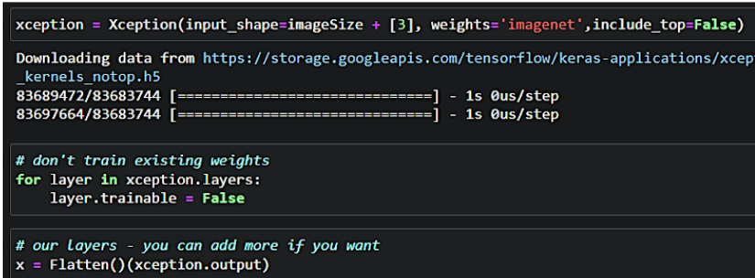

### Adding Dense Layers

A dense layer is a deeply connected neural network layer. It is the most common and frequently used layer.

Let us create a model object named model with inputs as xception. input and output as dense layer.

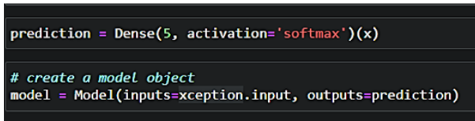

The number of neurons in the Dense layer is the same as the number of classes in the training set. The neurons in the last Dense layer, use softmax activation to convert their outputs into respective probabilities.

Understanding the model is a very important phase to properly use it for training and prediction purposes. Keras provides a simple method, summary to get the full information about the model and its layers.

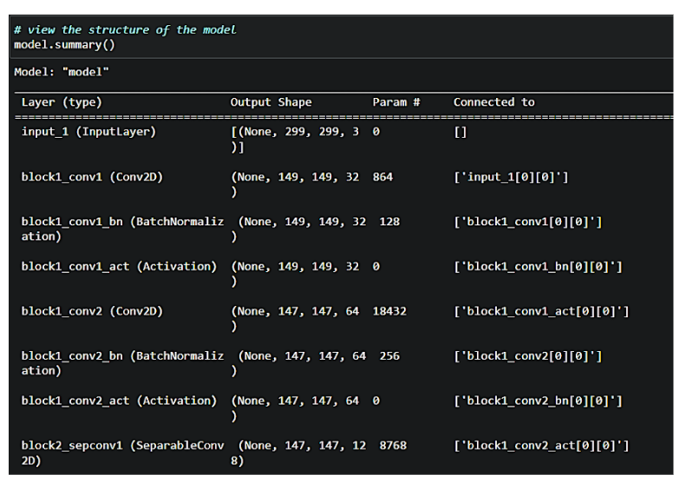

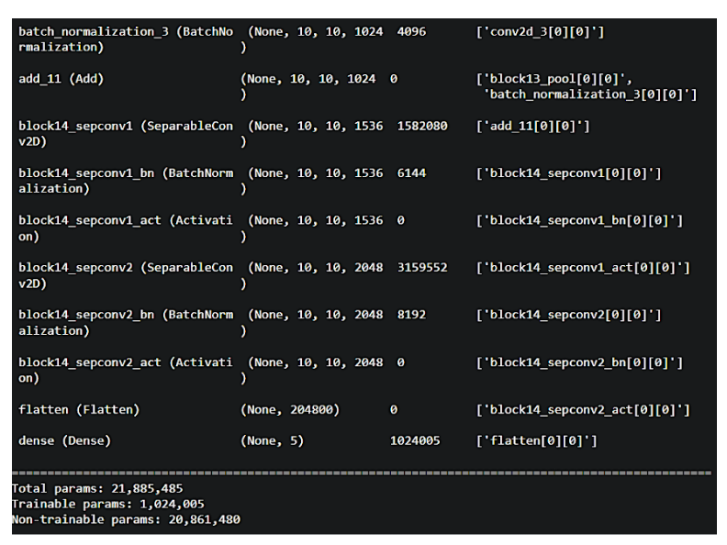

**Configure The Learning Process**

The compilation is the final step in creating a model. Once the compilation is done, we can move on to the training phase. The loss function is used to find errors or deviations in the learning process. Keras requires a loss function during the model compilation process.

Optimization is an important process that optimizes the input weights by comparing the prediction and the loss function. Here we are using adam optimizer

Metrics are used to evaluate the performance of your model. It is similar to the loss function, but not used in the training process

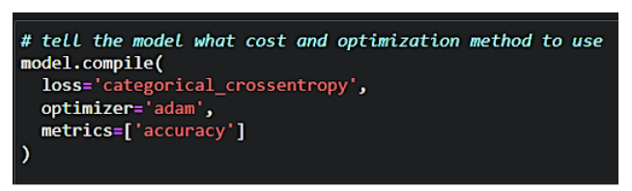

**Train The Model**

Now, let us train our model with our image dataset. The model is trained for 30 epochs and after every epoch, the current model state is saved if the model has the least loss encountered till that time. We can see that the training loss decreases in almost every epoch till 10 epochs and probably there is further scope to improve the model.

**fit_generator** functions used to train a deep learning neural network

**Arguments:**

* steps_per_epoch: it specifies the total number of steps taken from the generator as soon as one epoch is finished and the next epoch has started. We can calculate the value of     steps_per_epoch as the total number of samples in your dataset divided by the batch size.
* Epochs: an integer and number of epochs we want to train our model for.
* validation_data can be either:

                      - an inputs and targets list

                      - a generator

                      - an inputs, targets, and sample_weights list which can be used to evaluate

                        the loss and metrics for any model after any epoch has ended.

* validation_steps:

only if the validation_data is a generator then only this argument can be used. It specifies the total number of steps taken from the generator before it is stopped at every epoch and its value is calculated as the total number of validation

### **Save The Model**

The model is saved with .h5 extension as follows

An H5 file is a data file saved in the Hierarchical Data Format (HDF). It contains multidimensional arrays of scientific data.

**model.save(‘CNN_IBM.h5’)**

**5. FLOWCHART**

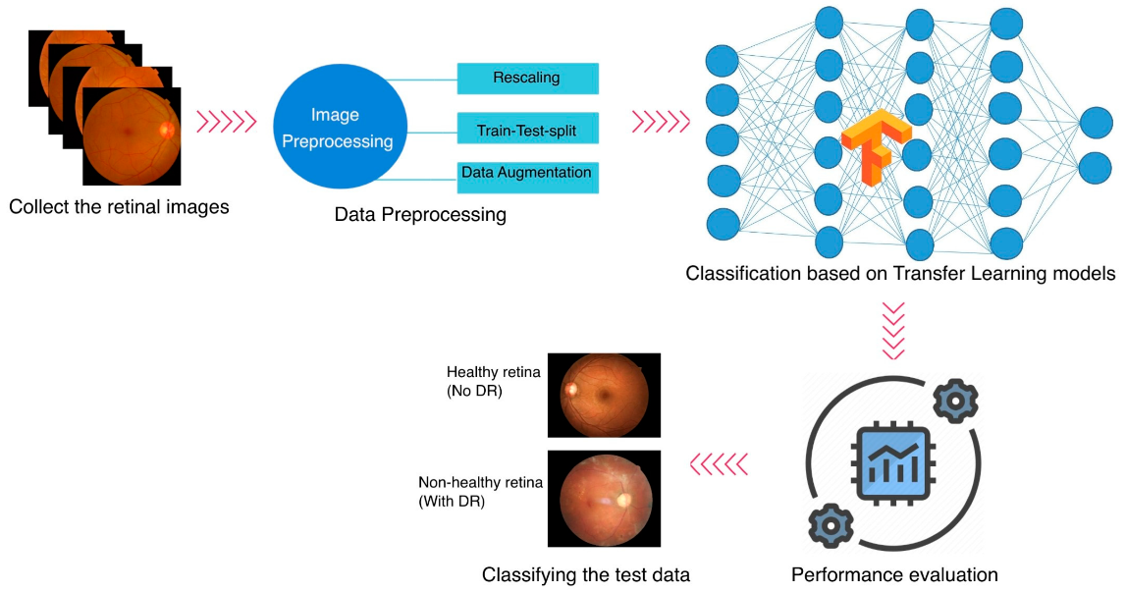

6. RESULT

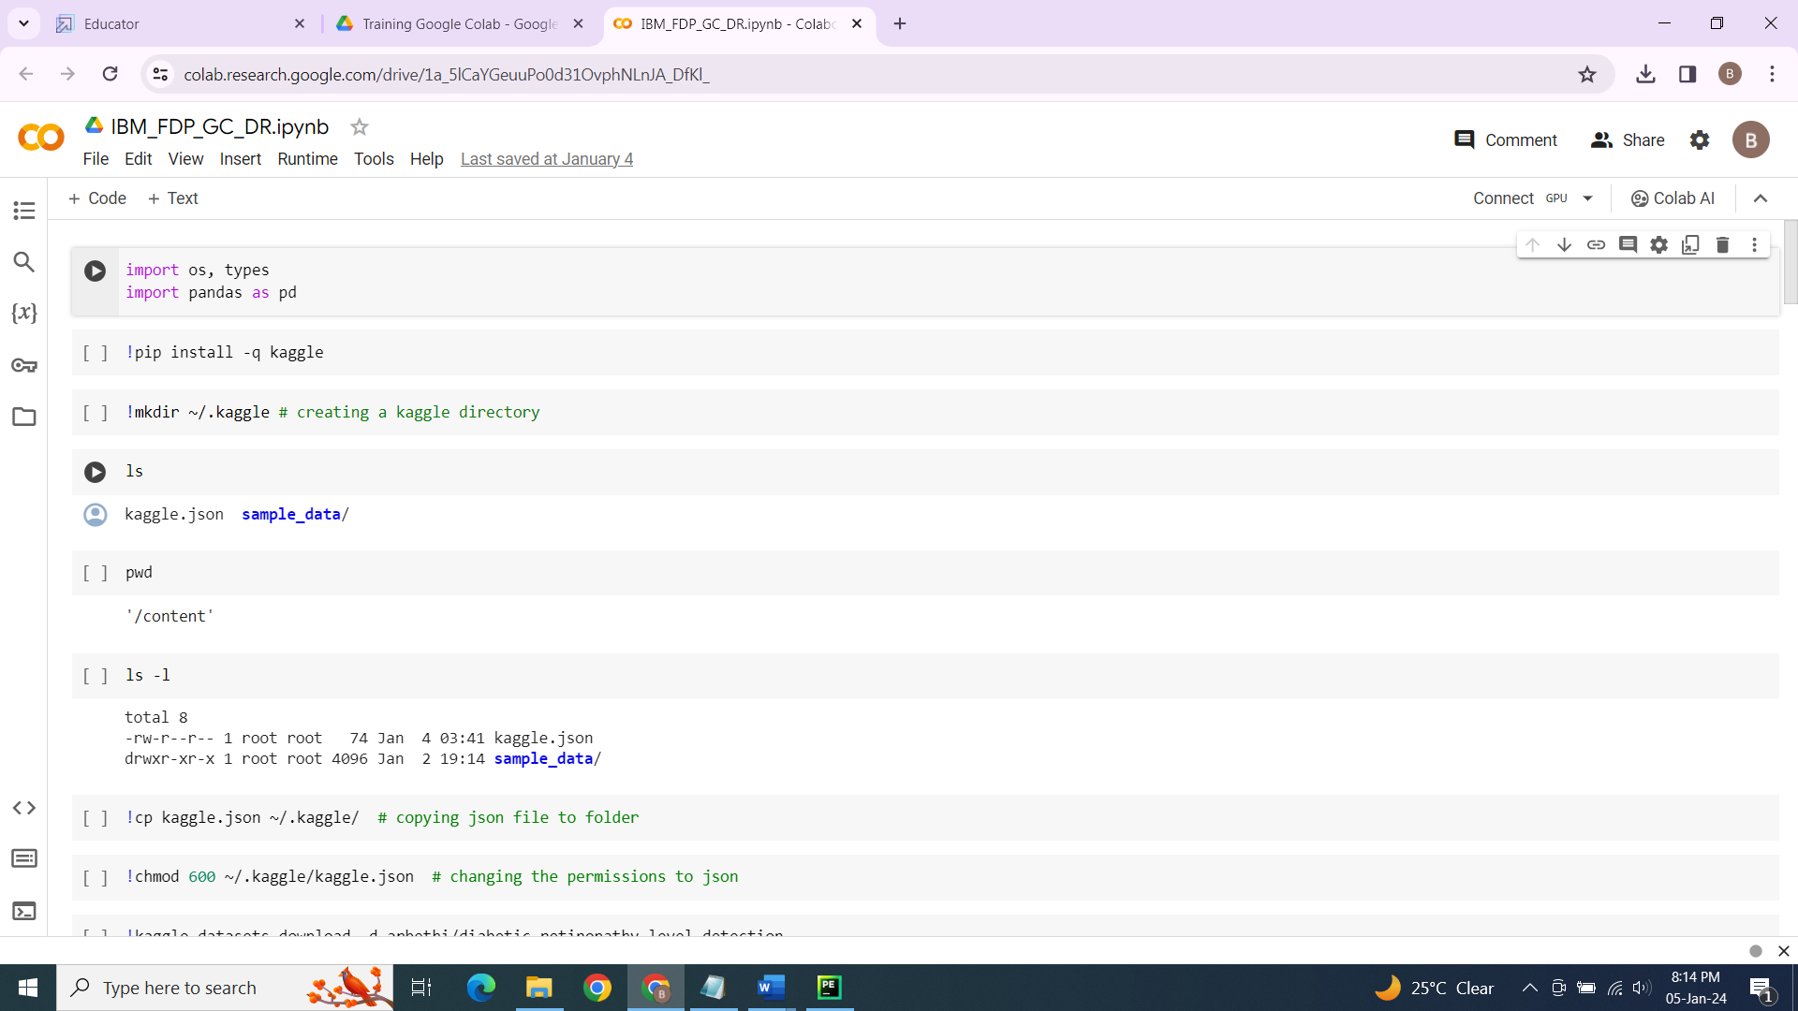

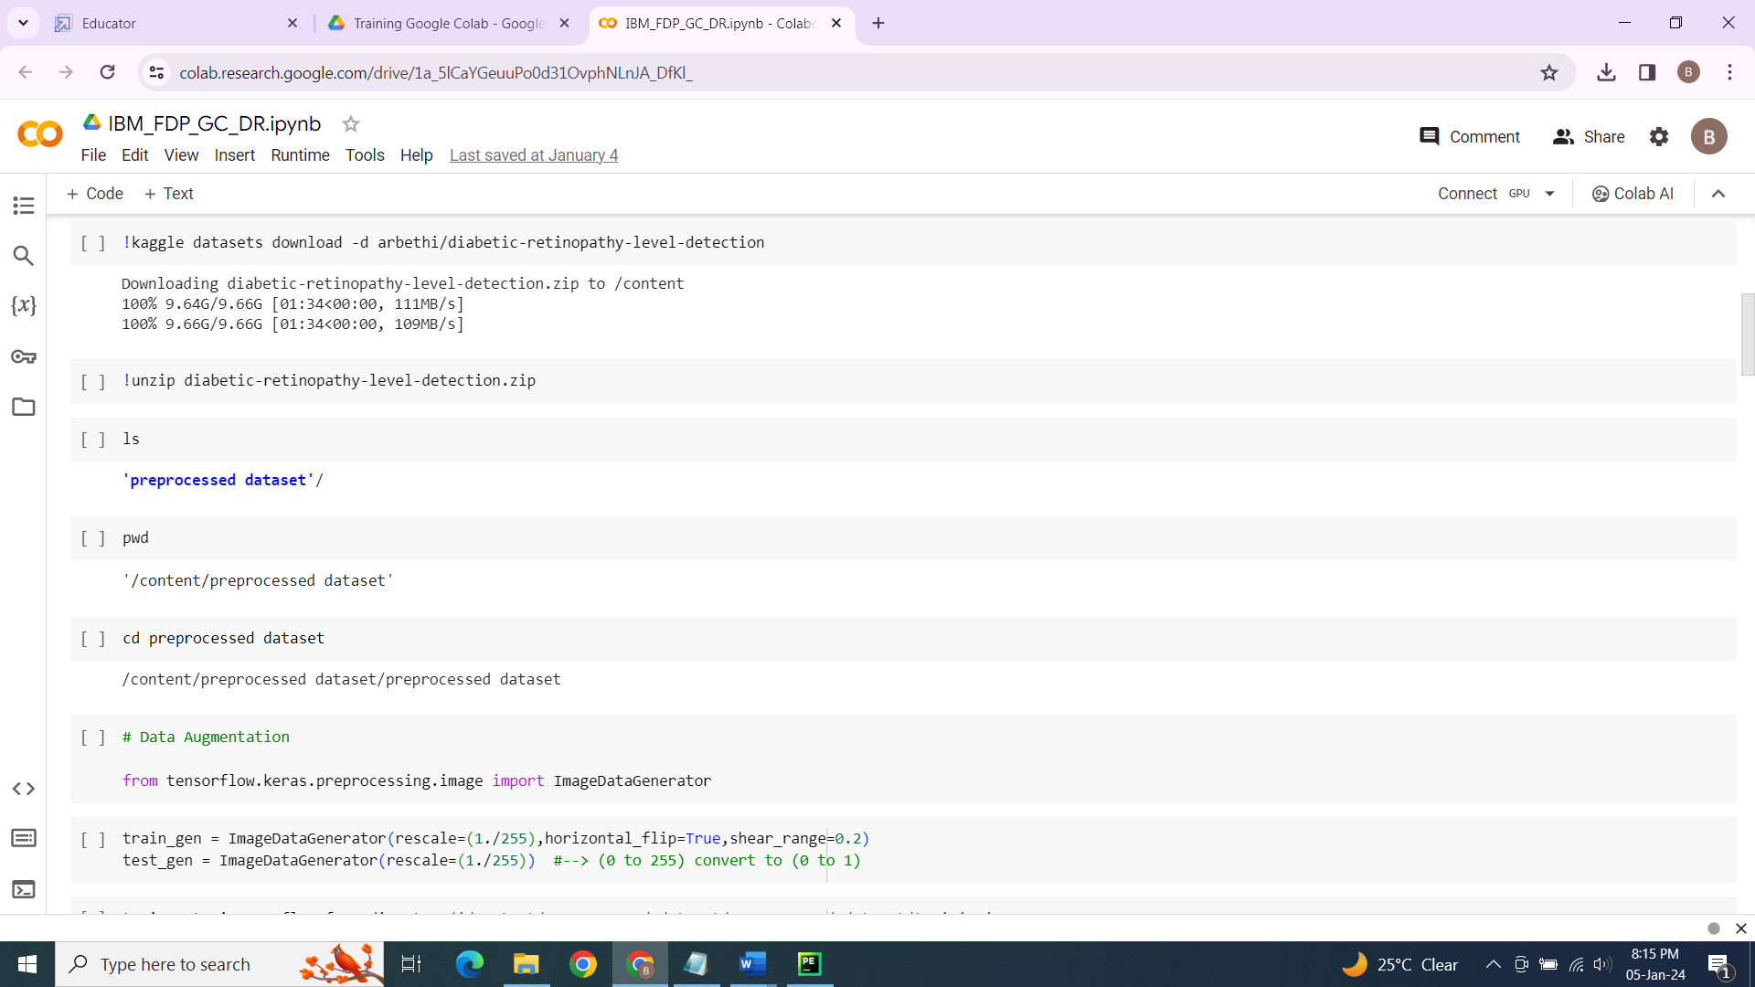

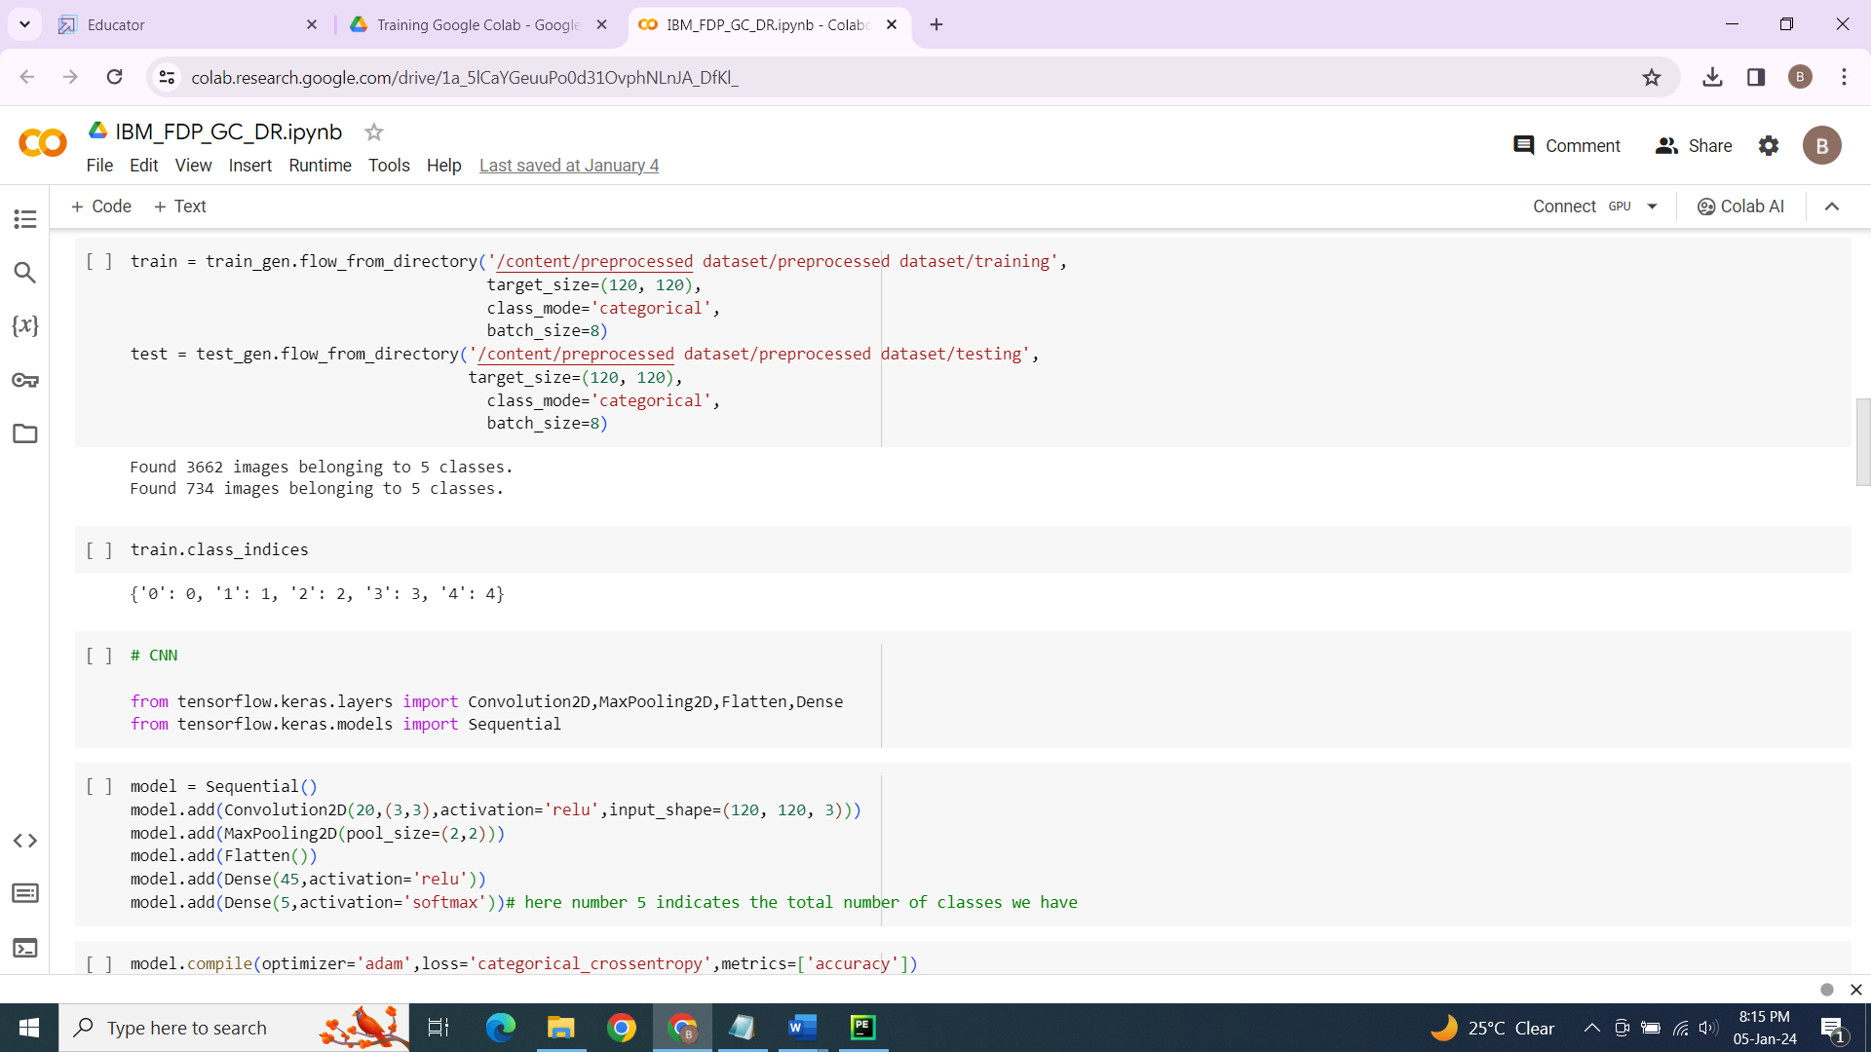

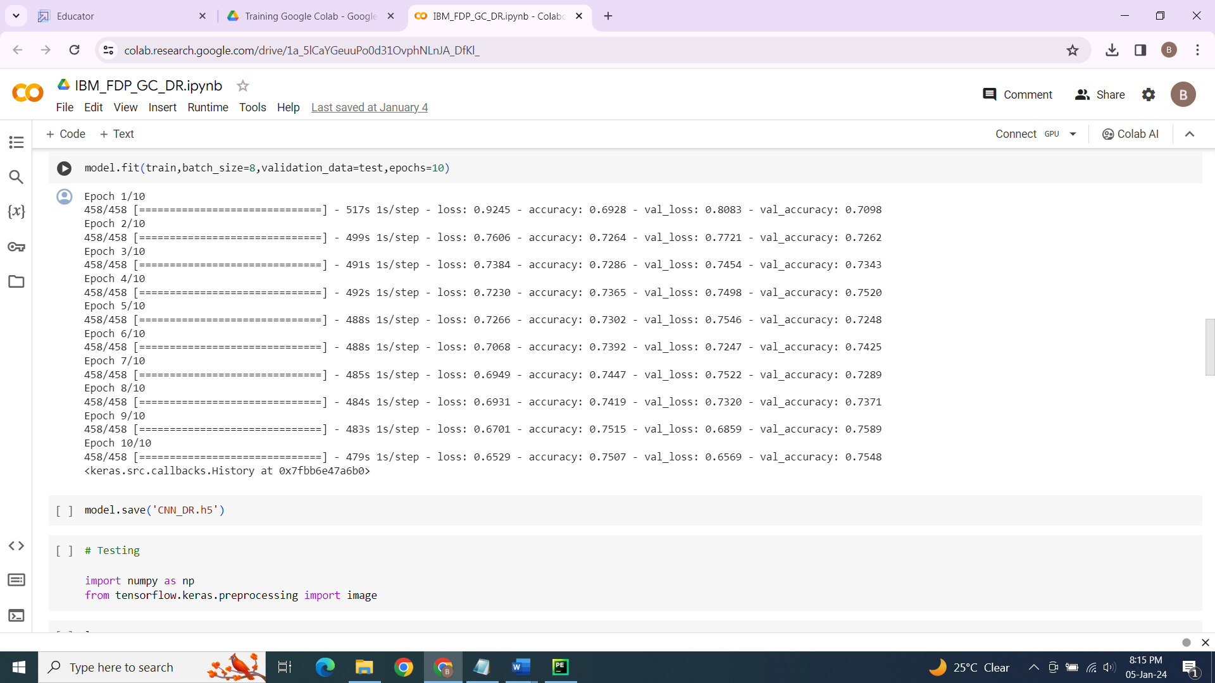

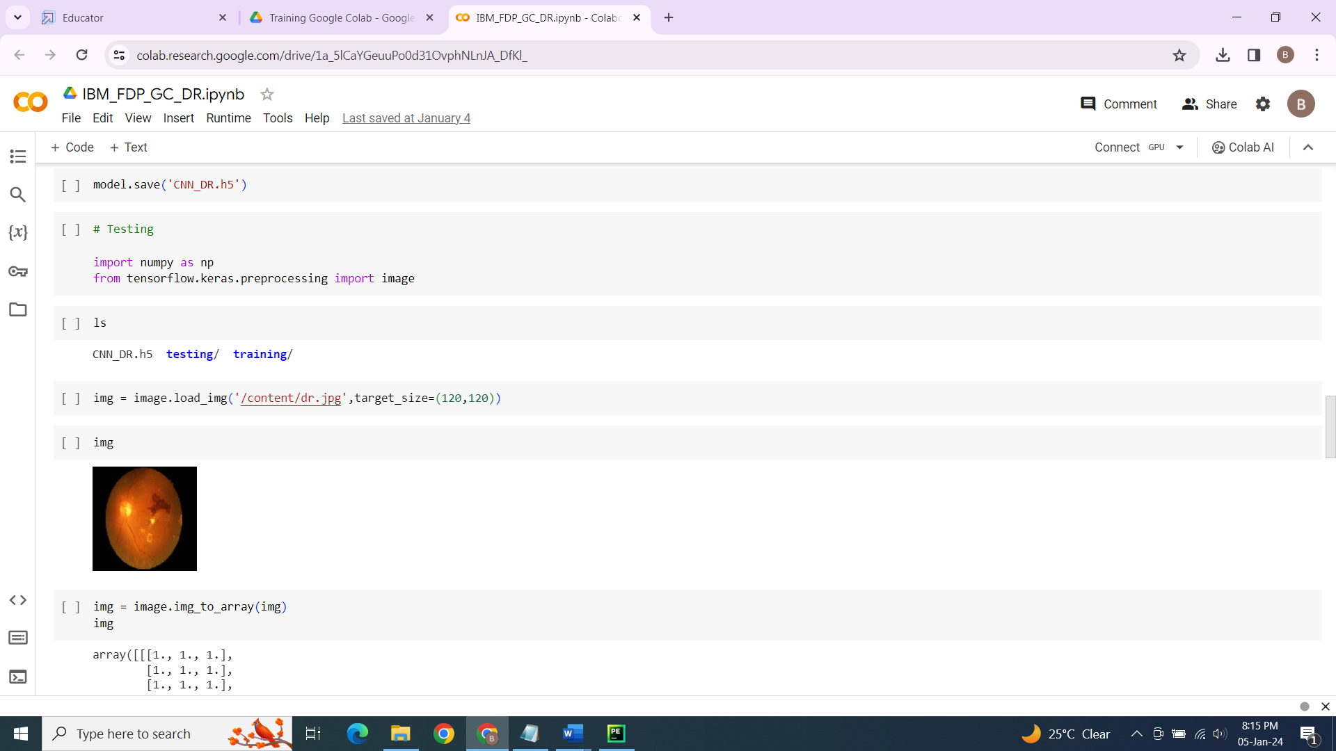

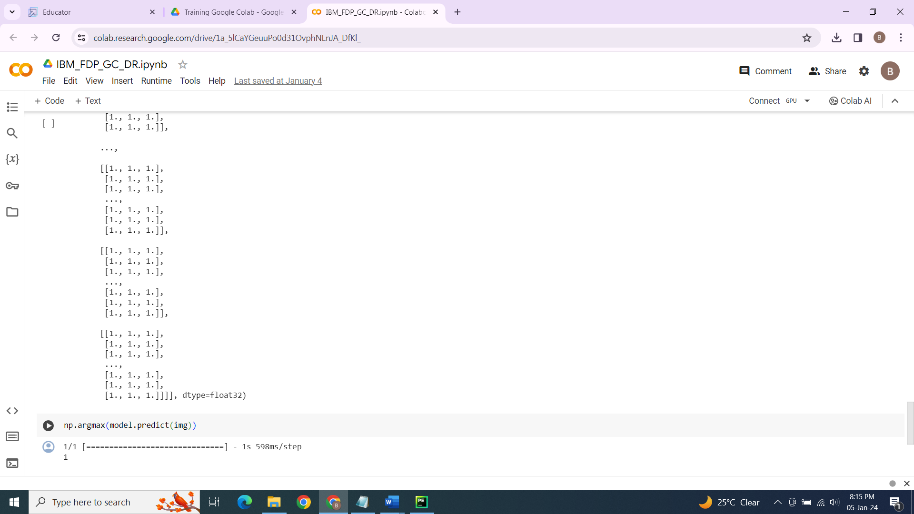

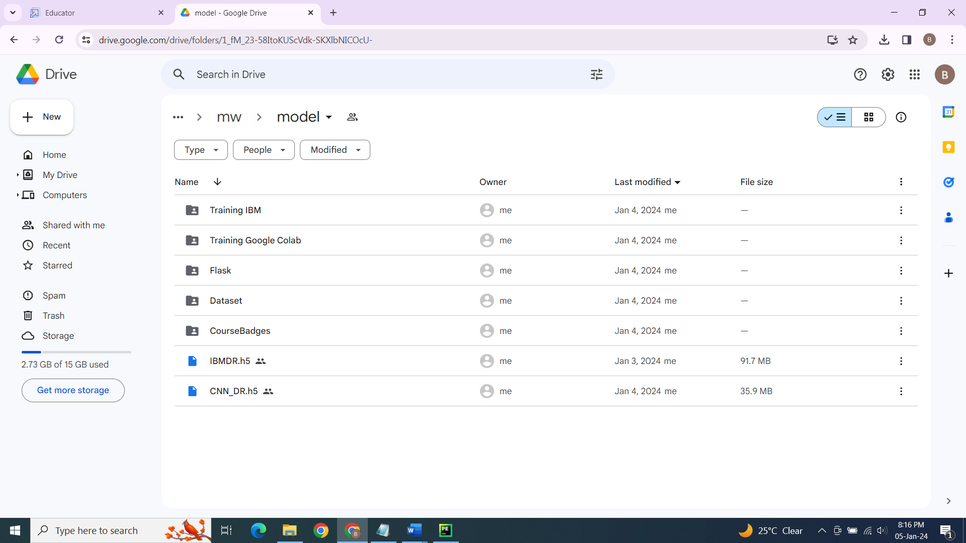

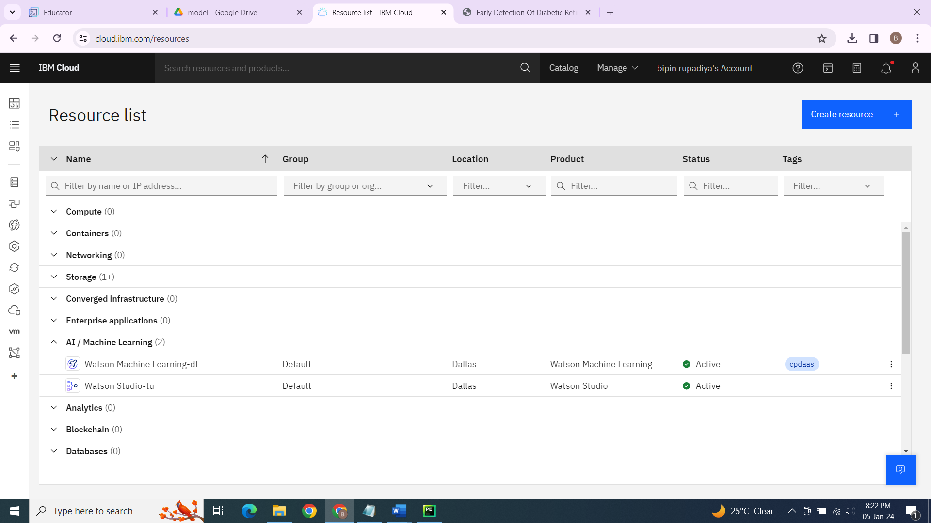

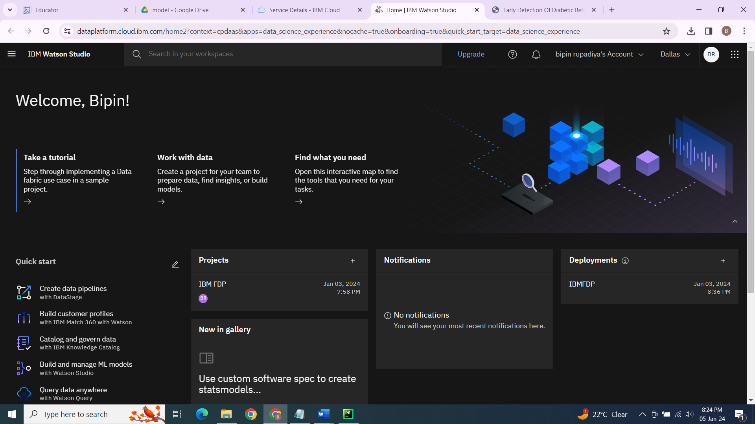

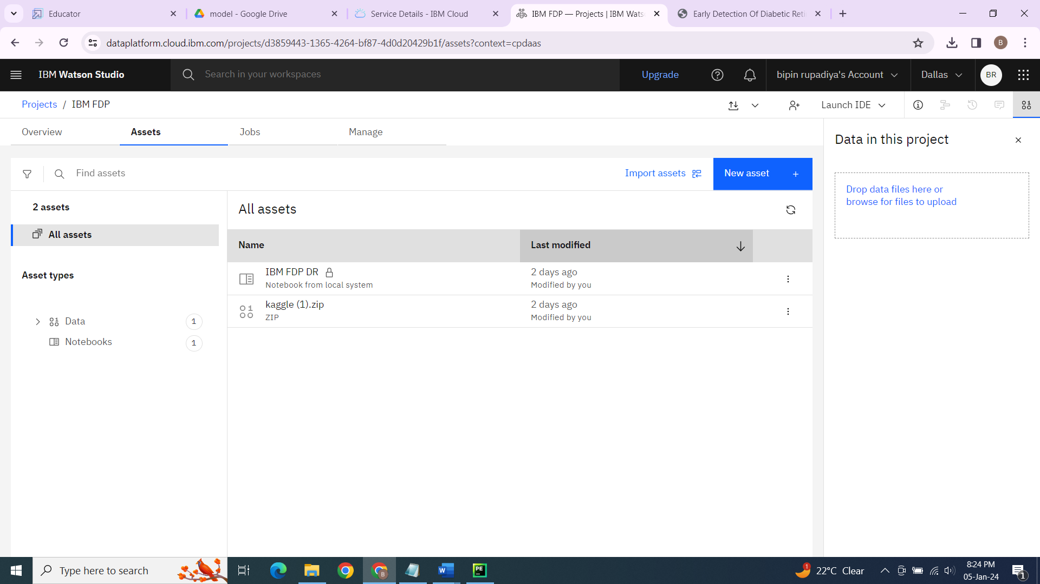

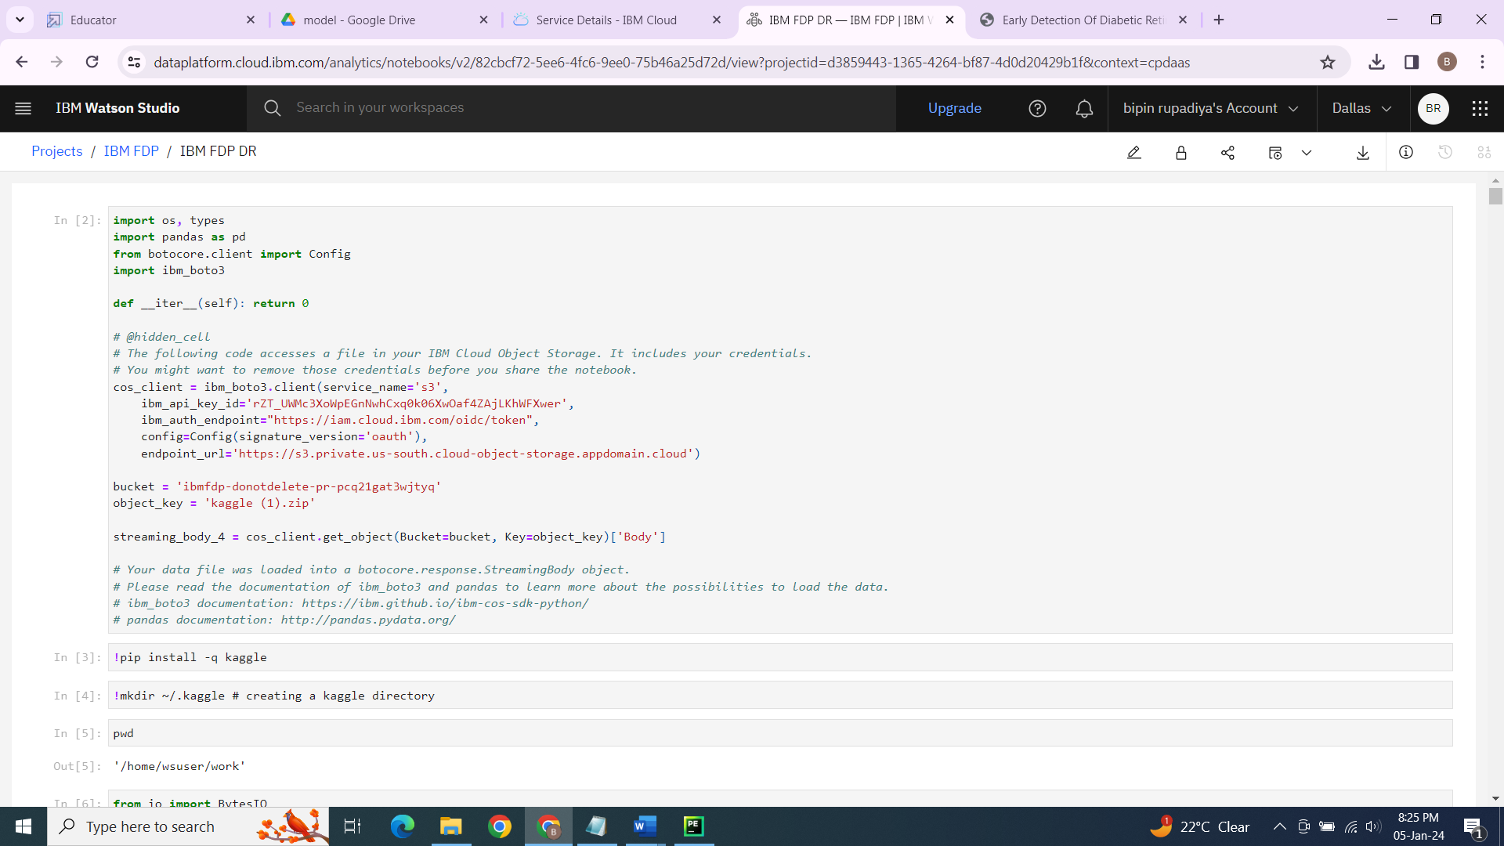

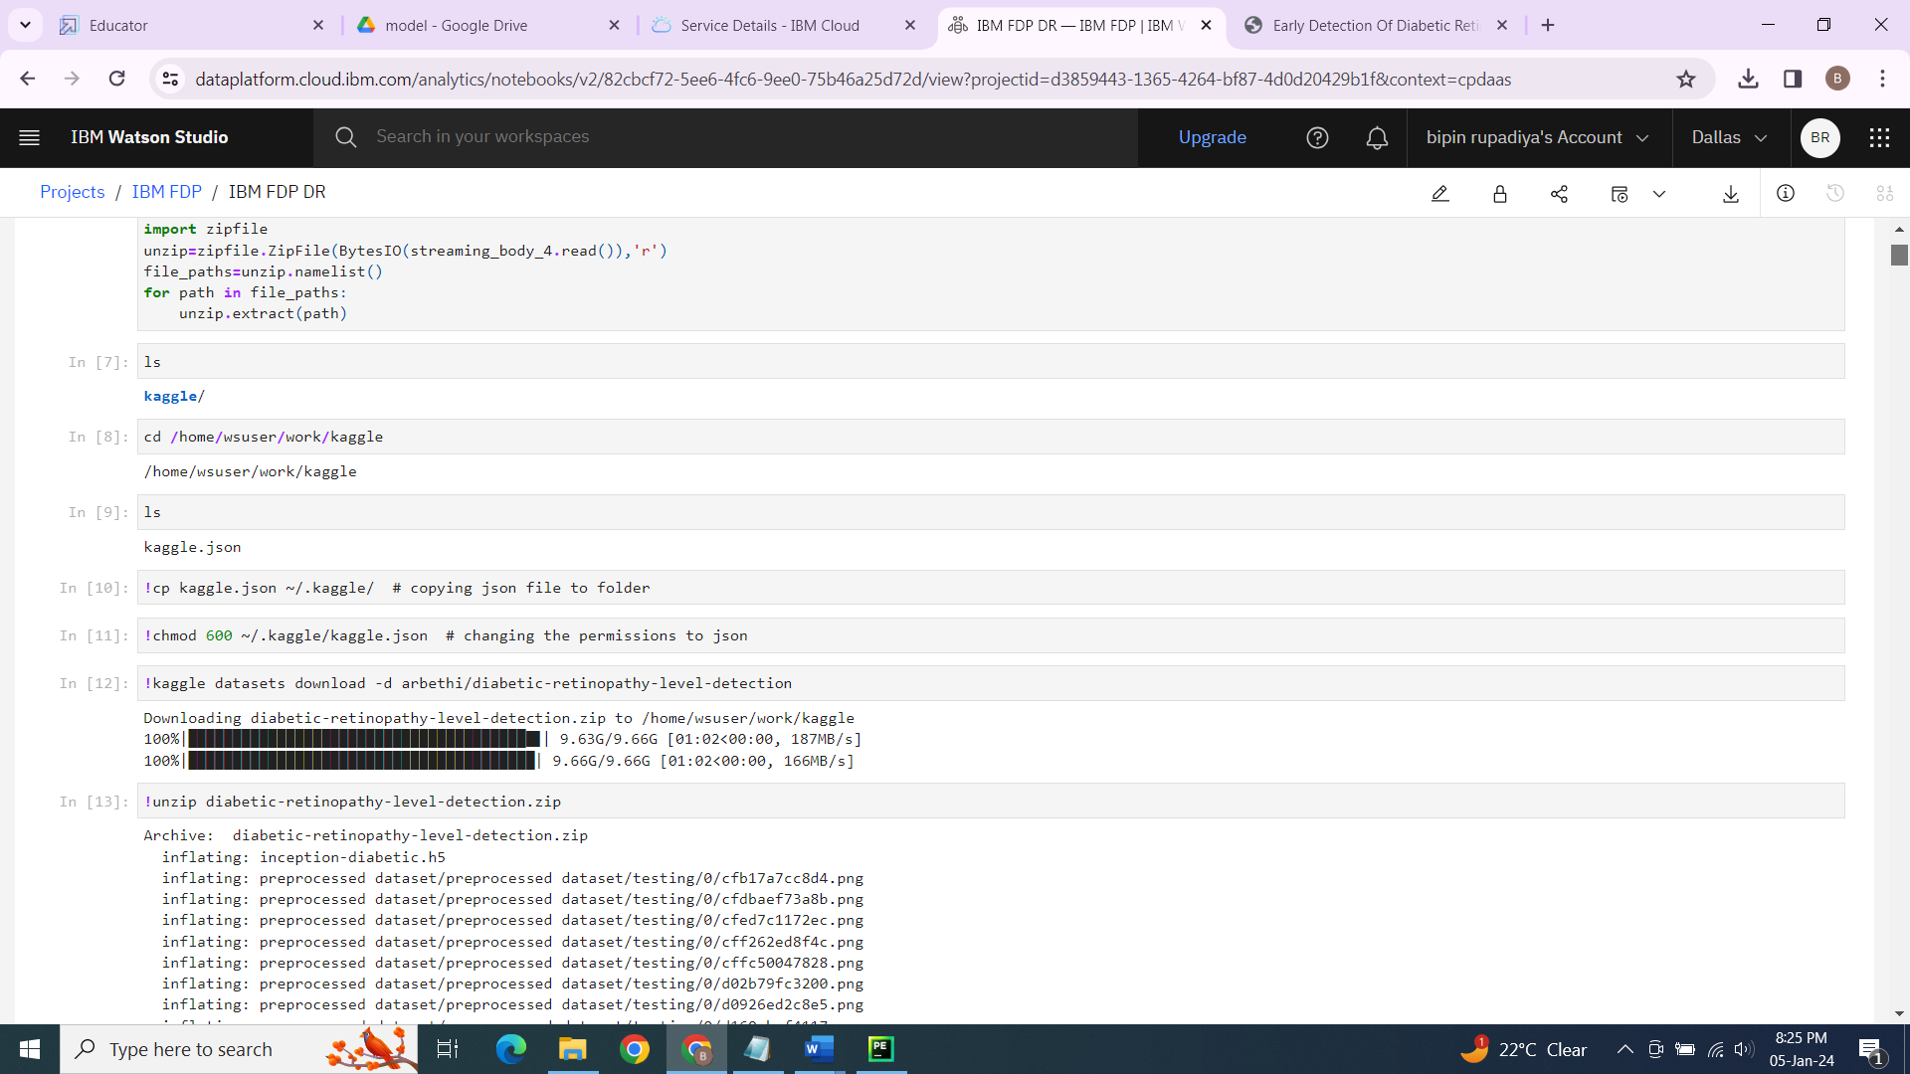

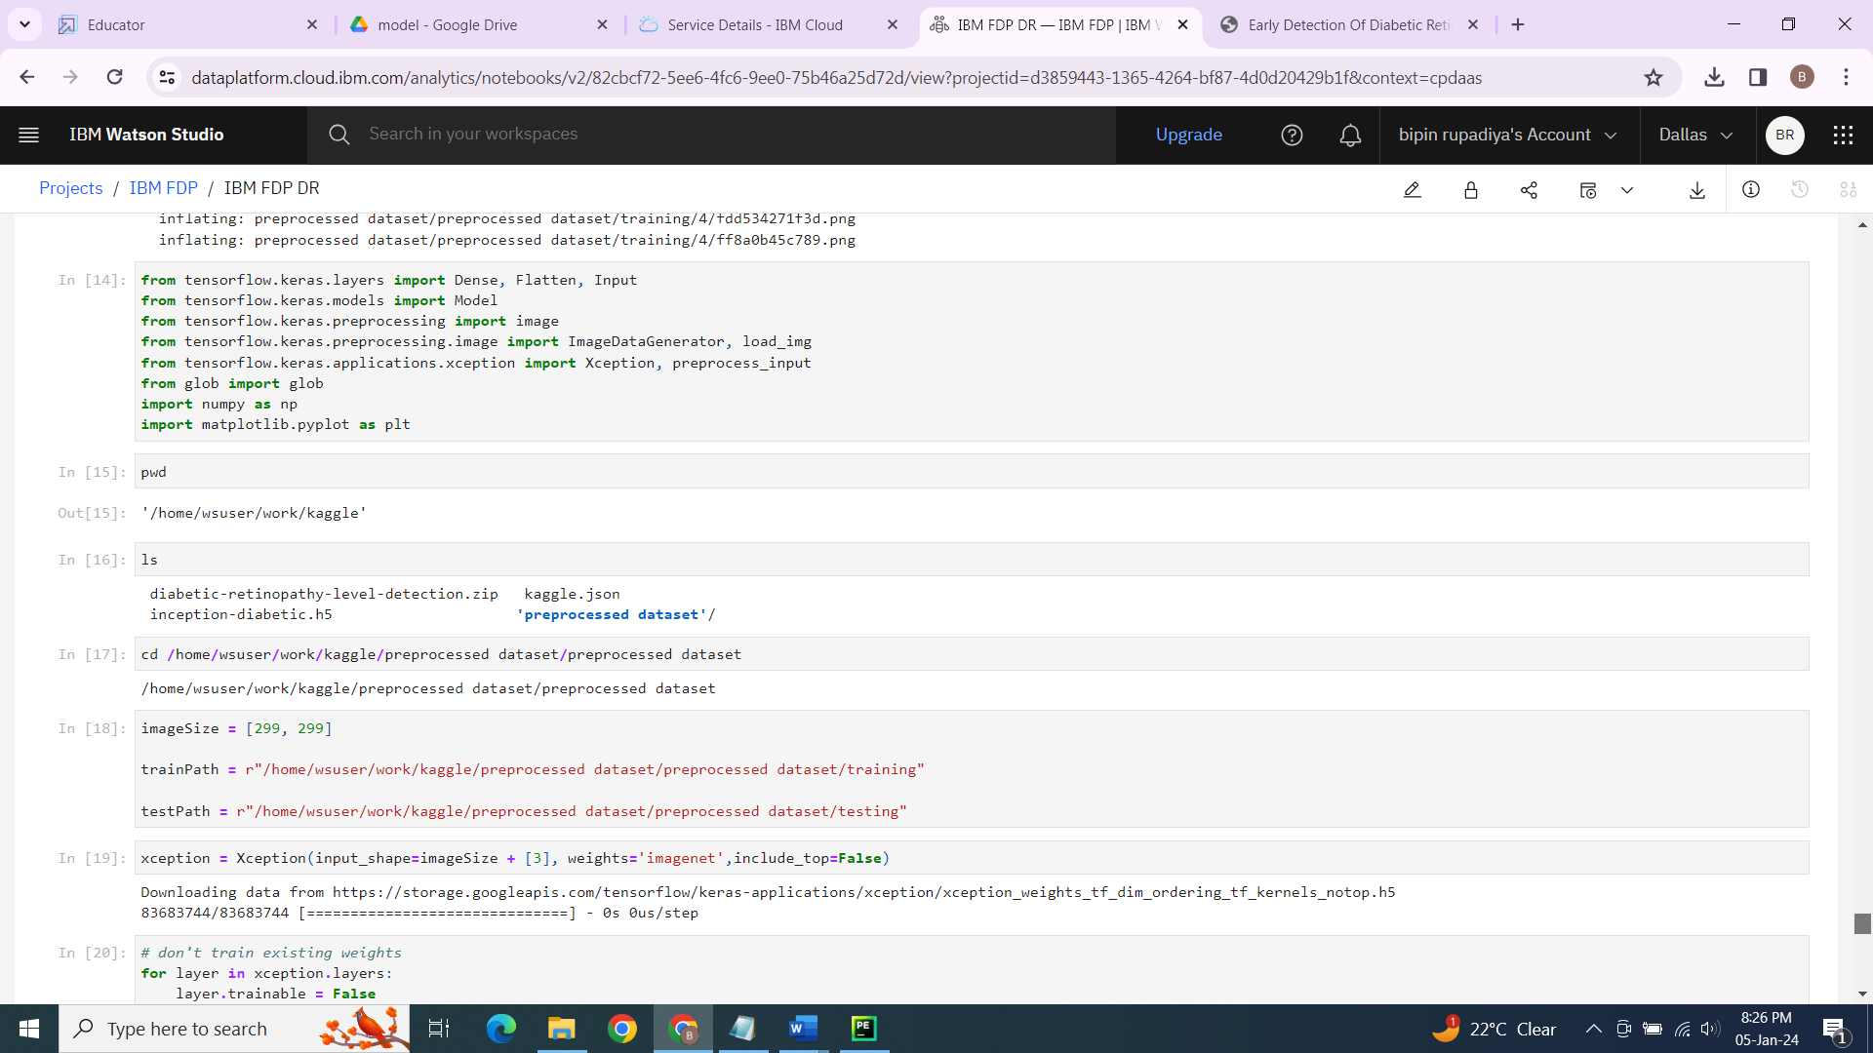

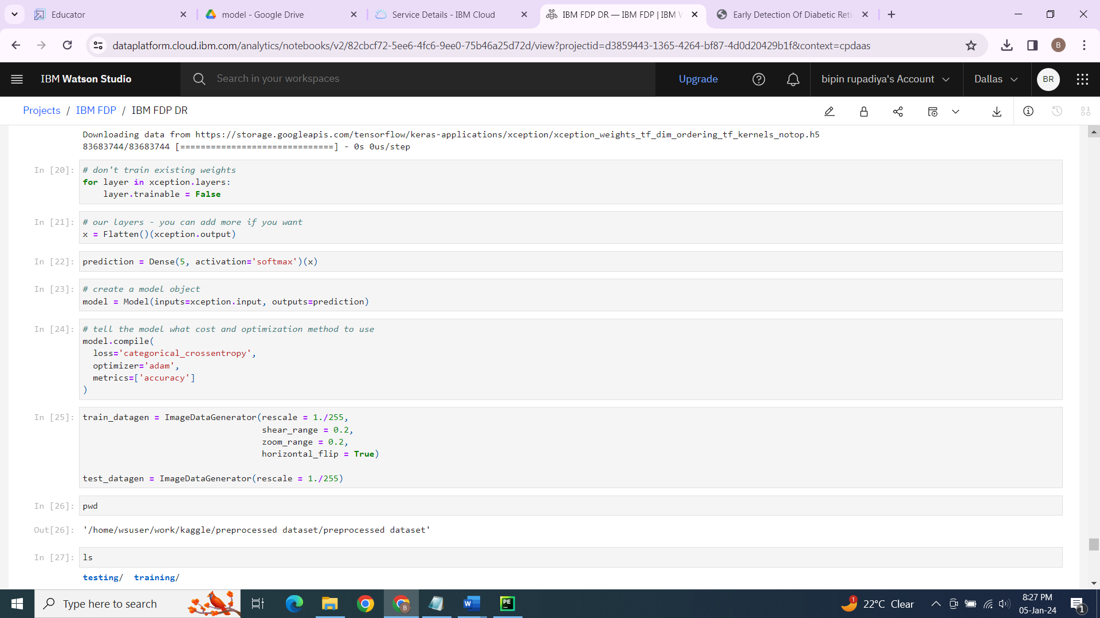

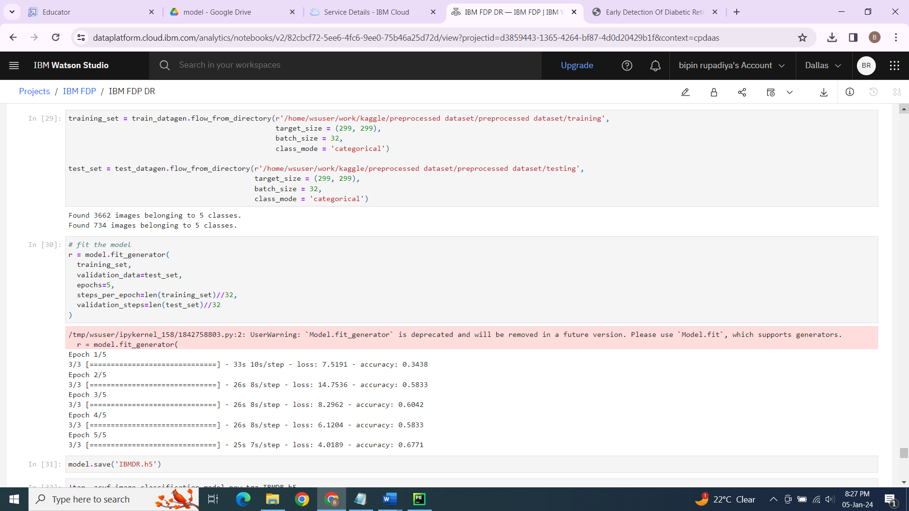

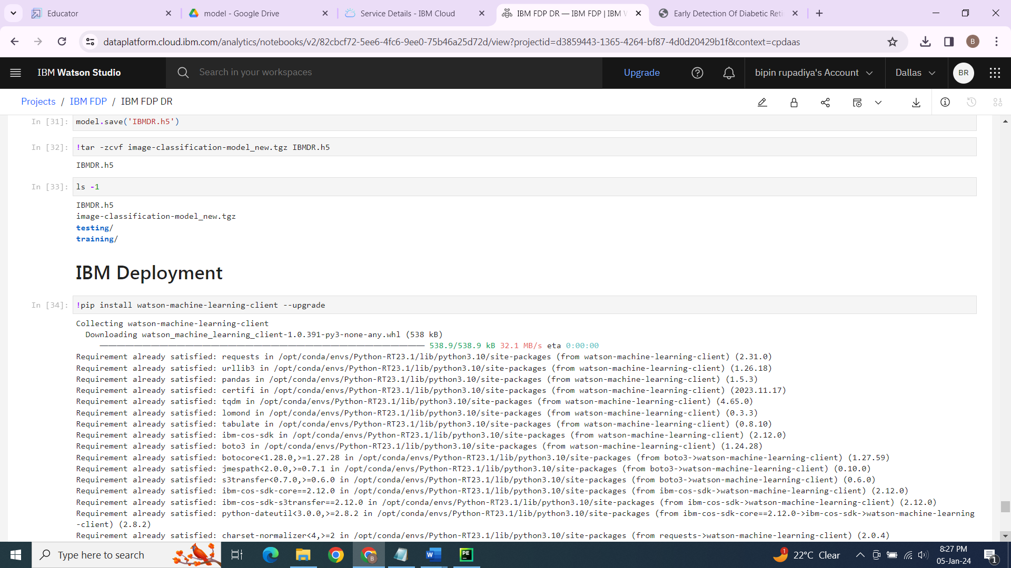

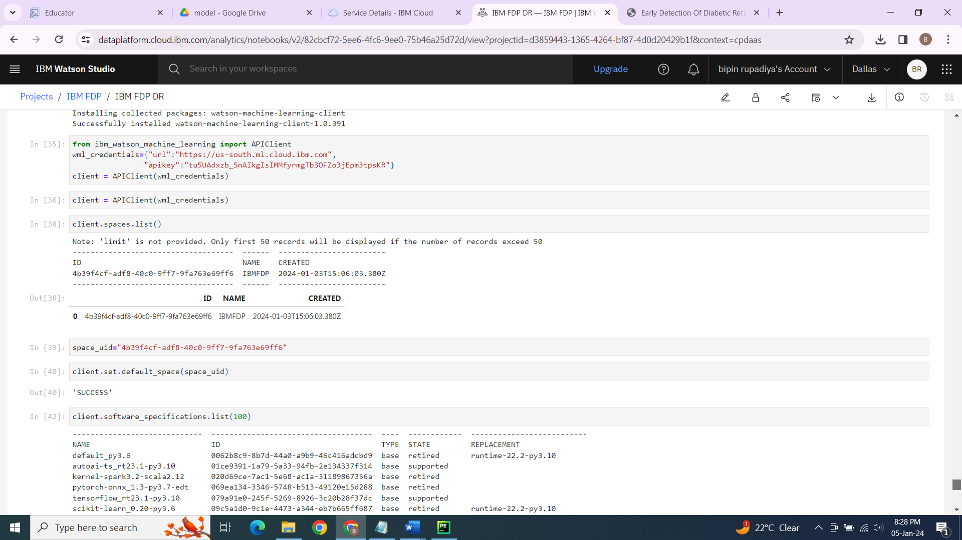

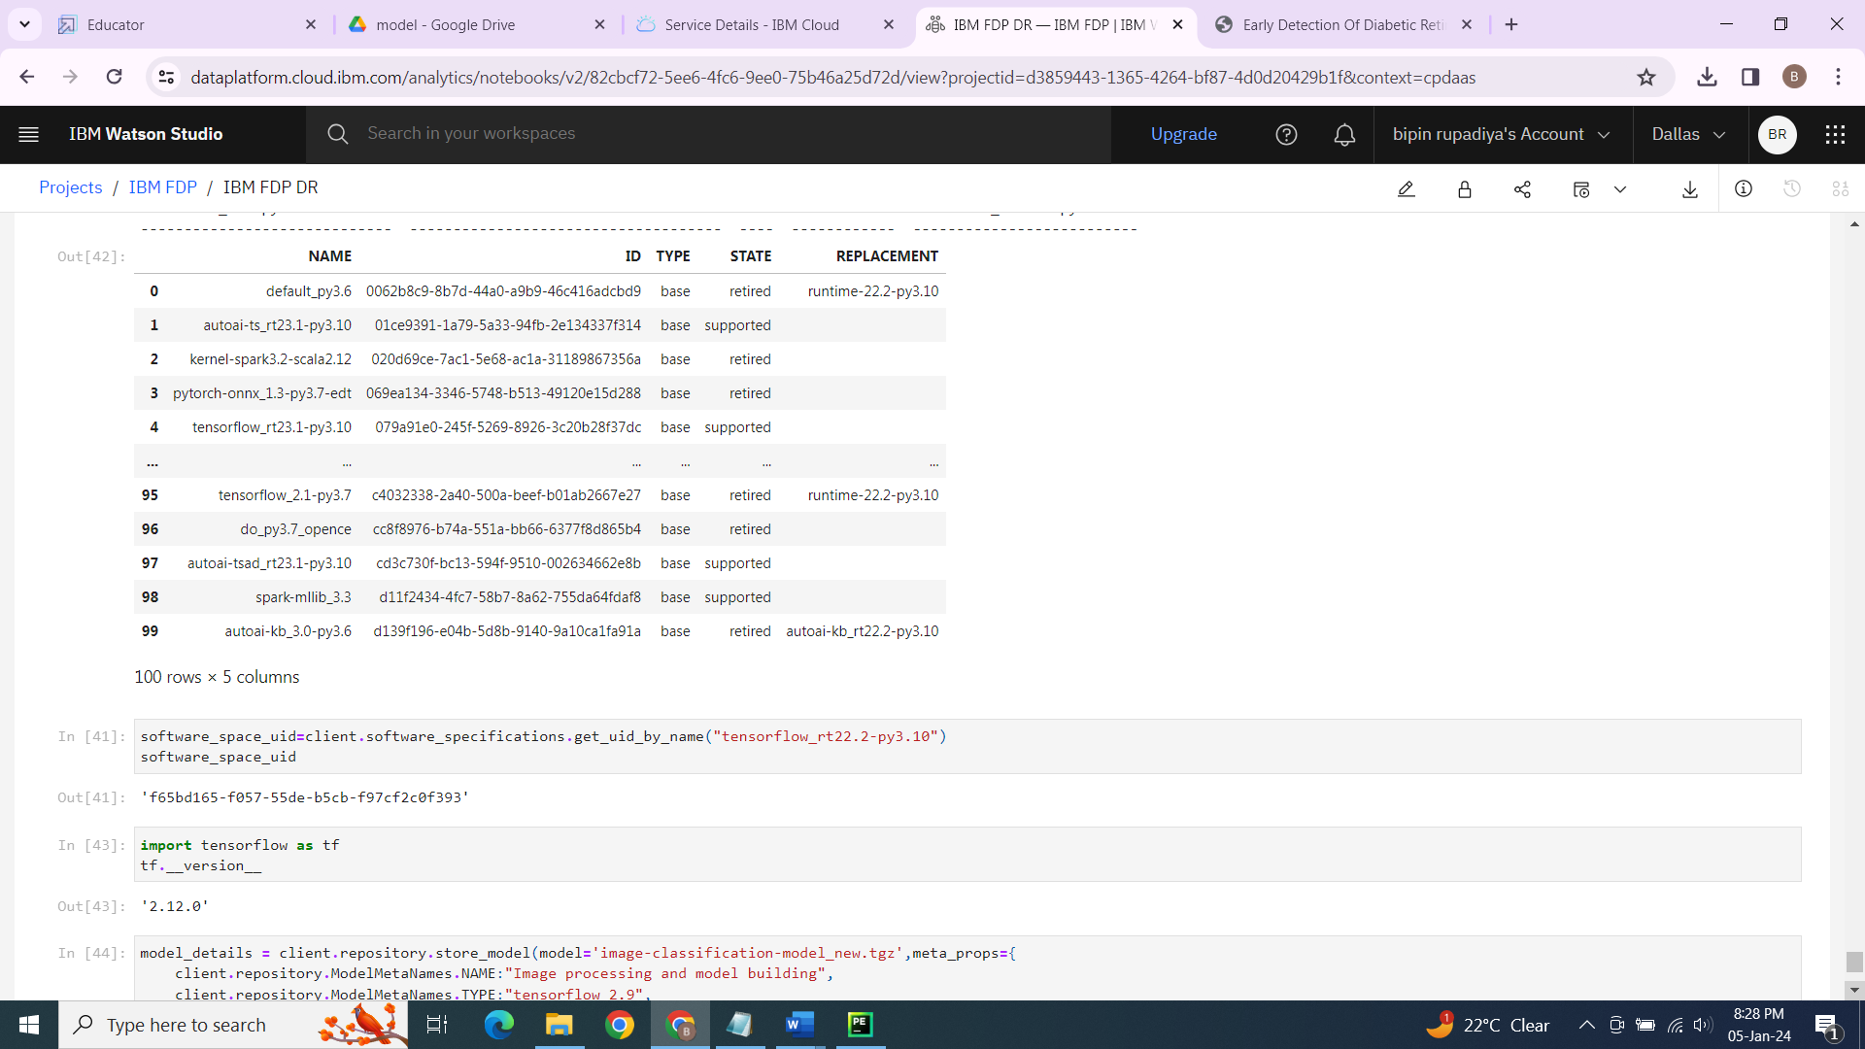

8. APPLICATIONS

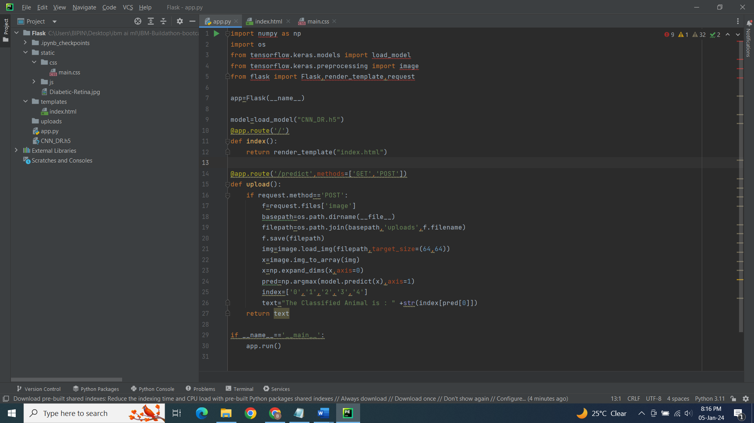

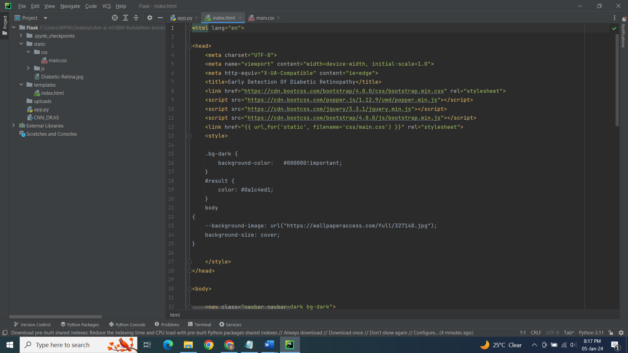

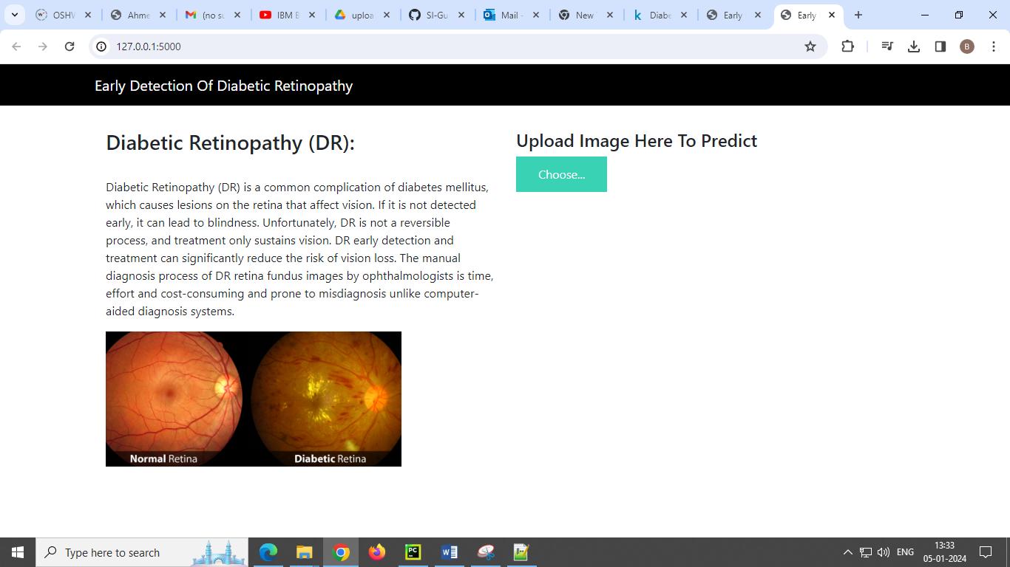

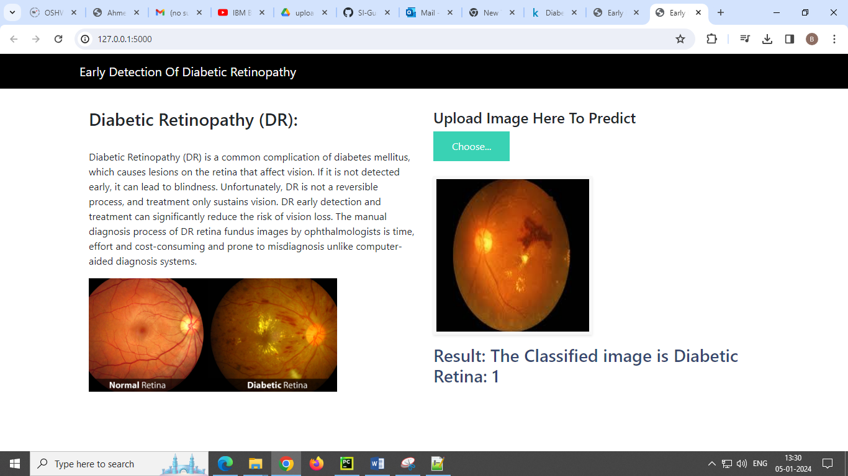

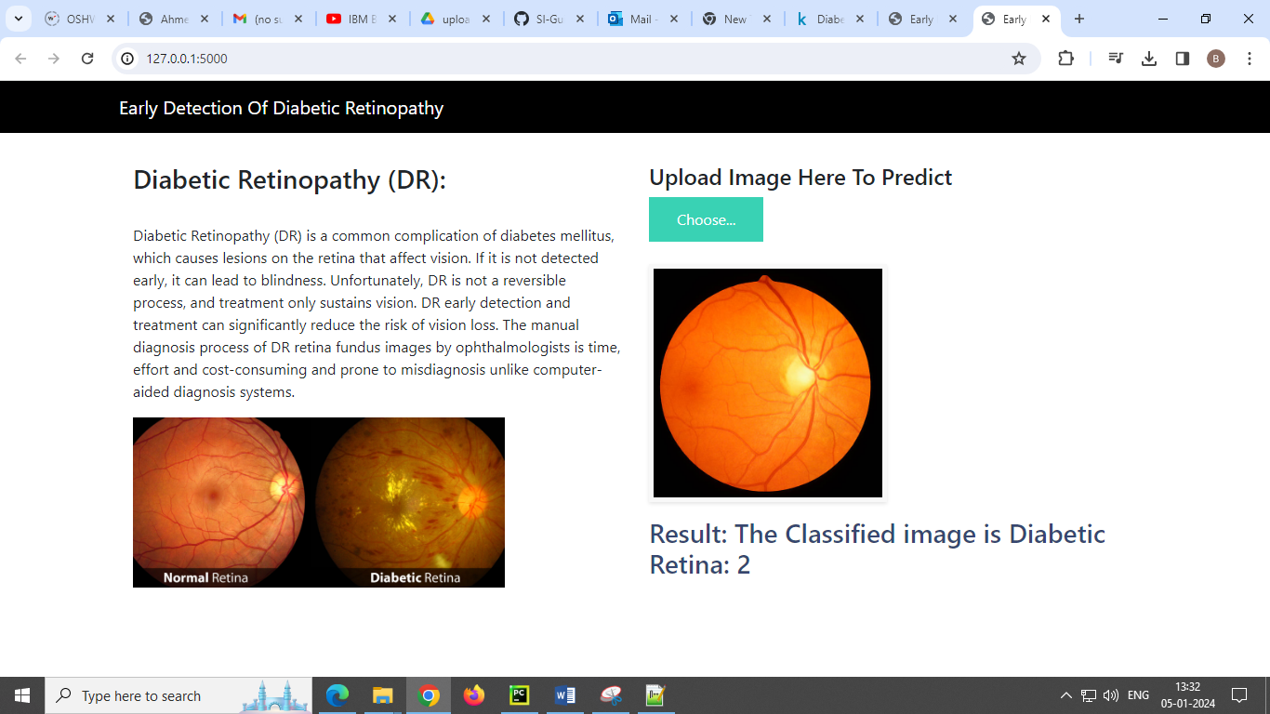

9. CONCLUSION

Deep learning has shown remarkable potential in detecting diabetic retinopathy (DR) through fundus image analysis. The application of convolutional neural networks (CNNs) and other deep learning techniques has significantly improved the accuracy and efficiency of early DR detection.

These algorithms can analyze fundus images to identify subtle abnormalities such as microaneurysms, hemorrhages, exudates, and other signs of diabetic retinopathy. The ability to detect these indicators at an early stage is crucial for timely intervention and prevention of vision loss in diabetic patients.

However, challenges remain, including the need for large and diverse datasets for training models, ensuring robustness against various image qualities, and the requirement for validation in real-world clinical settings. Additionally, interpretability of deep learning models in medical diagnosis is an ongoing concern, as clinicians often require explanations for the model's decisions.

10. FUTURE SCOPE

1. Enhanced Accuracy and Efficiency: Continued advancements in deep learning architectures and algorithms will likely lead to even higher accuracy rates in detecting diabetic retinopathy from fundus images. Improvement in model efficiency may allow for quicker analysis and diagnosis.
2. Personalized Medicine: Tailoring diagnosis and treatment plans to individual patients based on deep learning analysis of fundus images could become more prevalent. This could involve predicting disease progression or response to specific treatments based on a patient's unique retinal characteristics.
3. Integration into Healthcare Systems: There's a growing trend towards integrating AI models directly into healthcare systems. In the future, deep learning models for diabetic retinopathy detection could become a routine part of eye exams, assisting clinicians in early diagnosis and monitoring of the disease.
4. Mobile and Telemedicine Applications: With the increasing use of smartphones and telemedicine, there's potential for deep learning models to be deployed on mobile devices. This could enable quick and accessible retinal screening in remote or underserved areas, improving access to healthcare.
5. Multimodal Analysis: Integration of data from various imaging modalities (such as OCT - Optical Coherence Tomography) along with fundus images could enhance the accuracy of diagnosis and provide a more comprehensive understanding of the disease.

**11. BIBILOGRAPHY**

**Introduction to google colab:**

https://www.youtube.com/watch?v=vVe648dJOdI

**Dataset:**

https://www.kaggle.com/

**Clone the kaggle dataset on colab.:** https://www.analyticsvidhya.com/blog/2021/06/how-to-load-kaggle-datasets-directly-into-google-colab/

**SkillsBuild:**

https://www.ibm.com/academic/topic/artificial-intelligence

**IBM:**

https://www.ibm.com/academic/home

https://www.ibm.com/training/P430723G05904L37

**Python:**

https://www.python.org/

**Flask:**

https://flask.palletsprojects.com/en/3.0.x/

**APPENDIX**

* 1. **Source Code**

app.py

import numpy as np  
import os  
from tensorflow.keras.models import load_model  
from tensorflow.keras.preprocessing import image  
from flask import Flask,render_template,request  
  
app=Flask(__name__)  
model=load_model("CNN_DR.h5")  
  
@app.route('/')  
def index():  
 return render_template("index.html")  
  
@app.route('/predict',methods=['GET','POST'])  
def upload():  
 if request.method=='POST':  
 f=request.files['image']  
 basepath=os.path.dirname(__file__)  
 filepath=os.path.join(basepath,'uploads',f.filename)  
 f.save(filepath)  
 img=image.load_img(filepath,target_size=(120,120))  
 x=image.img_to_array(img)  
 x=np.expand_dims(x,axis=0)  
 pred=np.argmax(model.predict(x),axis=1)  
 index=['0','1','2','3','4']  
 text="The Classified image is Diabetic Retina: " +str(index[pred[0]])  
 return text  
  
if __name__=='__main__':  
 app.run()

index.html

<html lang="en">  
  
<head>  
 <meta charset="UTF-8">  
 <meta name="viewport" content="width=device-width, initial-scale=1.0">  
 <meta http-equiv="X-UA-Compatible" content="ie=edge">  
 <title>Early Detection Of Diabetic Retinopathy</title>  
 <link href="https://cdn.bootcss.com/bootstrap/4.0.0/css/bootstrap.min.css" rel="stylesheet">  
 <script src="https://cdn.bootcss.com/popper.js/1.12.9/umd/popper.min.js"></script>  
 <script src="https://cdn.bootcss.com/jquery/3.3.1/jquery.min.js"></script>  
 <script src="https://cdn.bootcss.com/bootstrap/4.0.0/js/bootstrap.min.js"></script>  
 <link href="{{ url_for('static', filename='css/main.css') }}" rel="stylesheet">   
 <style>  
   
 .bg-dark {  
 background-color: #000000!important;  
 }  
 #result {  
 color: #0a1c4ed1;  
 }  
 body  
{  
 --background-image: url("https://wallpaperaccess.com/full/327148.jpg");  
 background-size: cover;  
}  
  
 </style>  
</head>  
  
<body>  
   
 <nav class="navbar navbar-dark bg-dark">  
 <div class="container">  
 <a class="navbar-brand" href="#">Early Detection Of Diabetic Retinopathy</a>  
 </div>  
 </nav>  
 <div class="container">  
 <div id="content" style="margin-top:2em">  
 <div class="container">  
 <div class="row">  
 <div class="col-sm-6 bd">  
 <h3>Diabetic Retinopathy (DR): </h3>  
 <br>  
 <p>Diabetic Retinopathy (DR) is a common complication of diabetes mellitus, which causes lesions on the retina that affect vision. If it is not detected early, it can lead to blindness. Unfortunately, DR is not a reversible process, and treatment only sustains vision. DR early detection and treatment can significantly reduce the risk of vision loss. The manual diagnosis process of DR retina fundus images by ophthalmologists is time, effort and cost-consuming and prone to misdiagnosis unlike computer-aided diagnosis systems. </p>  
 <img src="{{ url_for('static', filename='Diabetic-Retina.jpg') }}" width="400px">  
 </div>  
 <div class="col-sm-6">  
 <div>  
 <h4>Upload Image Here To Predict</h4>  
 <form action = "http://localhost:5000/" id="upload-file" method="post" enctype="multipart/form-data">  
 <label for="imageUpload" class="upload-label">  
 Choose...  
 </label>  
 <input type="file" name="image" id="imageUpload" accept=".png, .jpg, .jpeg">  
 </form>  
   
  
 <div class="image-section" style="display:none;">  
 <div class="img-preview">  
 <div id="imagePreview">  
 </div>  
 </div>  
 <div>  
 <button type="button" class="btn btn-info btn-lg " id="btn-predict">Predict!</button>  
 </div>  
 </div>  
  
 <div class="loader" style="display:none;"></div>  
  
 <h3>  
 <span id="result"> </span>  
 </h3>  
  
 </div>  
 </div>  
   
 </div>  
 </div>  
 </div>  
 </div>  
</body>  
  
<footer>  
 <script src="{{ url_for('static', filename='js/main.js') }}" type="text/javascript"></script>   
</footer>  
  
</html>